



Student Exam Scheduler

 **Team:**

**Chelaru Ioana**

**Cîrstea Ștefan**

Contents

1. Introduction ………………………………………………………………………………………………………………..3
   1. Purpose of the document …………………………………………………………………………………….3
   2. Objectives …………………………………………………………………………………………………………….3
   3. Minimum Pre-requisites for automation ………………………………………………………………3
2. AS IS process description ……………………………………………………………………………………………..3
   1. Process Overview …………………………………………………………………………………………………3
   2. Applications used in the process ………………………………………………………………………….4
   3. Process steps description ……………………………………………………………………..……………..4
      1. The Get info about student sequence ………………………………………………………….5
      2. The Find appropriate document sequence ………………………………………………….6

# **Introduction**

## I.1 Purpose of the document

The Process Definition Document outlines the business process chosen for automation using UiPath Robotic Process Automation (RPA) technology.

The document describes the sequence of steps performed as part of the business process, the conditions and rules of the process prior to automation and how they are envisioned to work after automating it, partly or entirely. This specifications document serves as a base for developers, providing them the details required for applying robotic automation to the selected business process.

## I.2 Objectives

The business objectives and benefits expected by the University after automation of the selected business process are:

* Creating an event in the specified Google Calendar account for each exam of the given student
* Sending an email to the given student after updating his Google Calendar

### 

## I.3 Minimum Pre-requisites for automation

1. Excel document filled with the student data
2. The University’s files with the exam dates
3. Access to an already logged in Google account
4. Access to Google Chrome browser and internet

## AS IS process description

### II.1 Process Overview

General information about the process selected for RPA prior to automation.

|  |  |  |
| --- | --- | --- |
| # | Item | Description |
| 1 | **Process full name** | Student Exam Scheduler |
| 2 | **Process short description** | Create and add the events in the Google Calendar and send the confirmation email |
| 3 | **Role(s) required for performing the process** | ACME System 1 – Role name Fin ACC:  Module “ Work Items” – Rights “ Read &Write” |
| 4 | **Process schedule and frequency** | Twice a year, when the exam dates are posted. |
| 5 | **Input data** | .xlsx file with the student’s data and the .docx files from the university’s website |
| 6 | **Output data** | The events created and the email sent to the student |

## II.2. Applications used in the process

The table includes a comprehensive list all the applications that are used as part of the process automated, at various steps in the flow.

|  |  |  |  |  |  |
| --- | --- | --- | --- | --- | --- |
| # | Application name & version | System  Language | Thin/Thick Client | Environment/  Access method | Comments |
| 1 | Email | EN | Thick Client | Google Chrome | Email Sending |
| 2 | Google Calendar | EN | Thick Client | Google Chrome | Create an event |
| 3 | Microsoft Office | EN | Thick Client | Microsoft Office | Word and Excel documents |

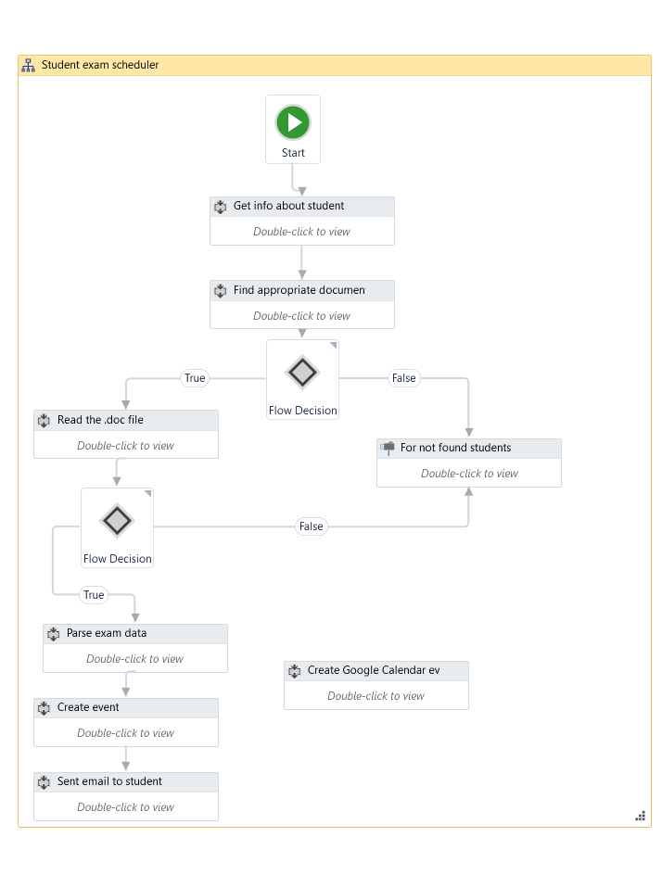

### II.3. Process steps description

This is a general view over

the project structure:

It starts with the extraction of the student informations, followed by finding the document that contains the exam dates for that specific student. At this point, if the document could not be found an error message is displayed. Otherwise, the document is being read. If the number of the class that the student provided can’t be found, the same error message is being displayed, otherwise the robot goes on with the parsing data sequence, followed by accessing the Google Calendar using the Chrome Browser and closing it back. Here we’re missing a task, and that is creating the actual events. The final step is sending a confirmation email to the student at the email address that he provided at the beginning.

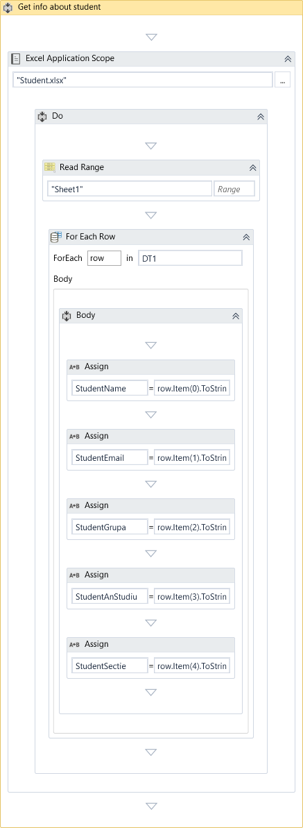

### II.3.1 The Get info about student sequence

In this sequence, the student data is being extracted by

iterating each row in the .xlsx file and attributed to global

variables (StudentName, StudentEmail, StudentGrupa,

StudentAnStudiu, StudentSectie), all of String type that are

to be used later in the project.

### II.3.2 The Find appropriate document sequence

The files that contain the exams data are being accessed and iterated until the file that fits the data that the student provided is found and its path is saved to a global variable. If no file that matches is found, then a Boolean variable is set to false and a message will be shown to the user.

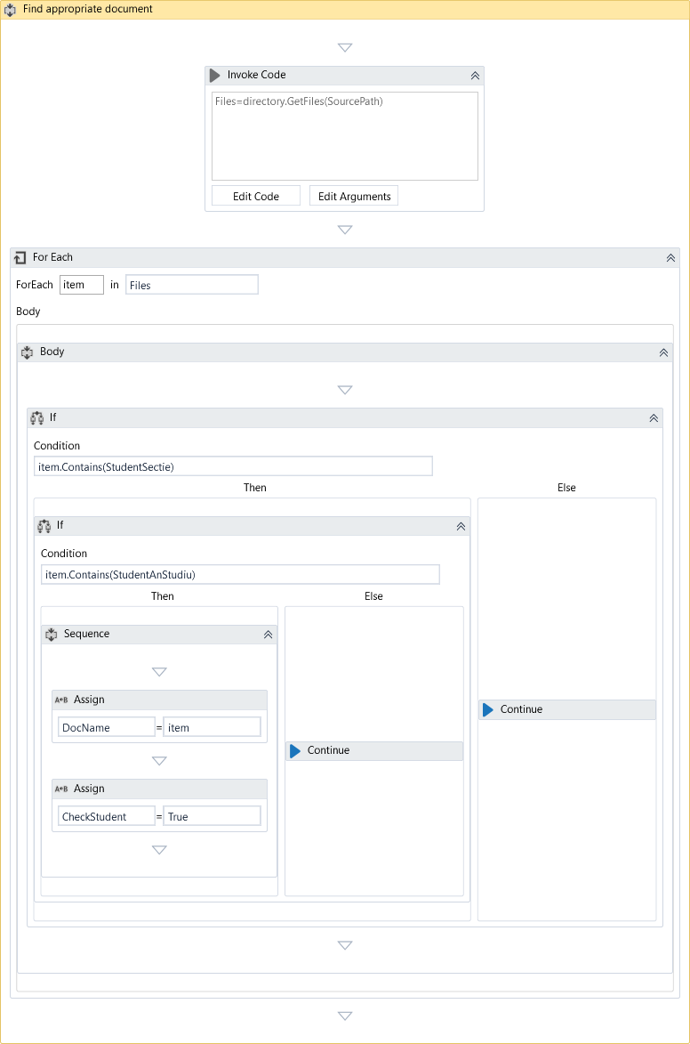

### II.3.3 The Read the .doc file

This sequence reads the text from the .doc file found earlier and checks if the number of the class that the student provided in the .xlsx file exists, and if not, an appropriate error message is being displayed for the user.

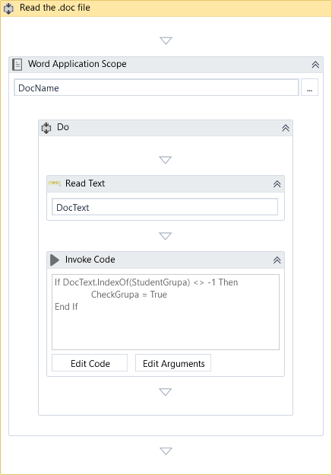

### II.3.4 The Parse exam data sequence

Here takes places the extraction of the data about the exams that correspond to the student. The ArrayFain String[] variable will be later used to obtain the details when creating the events and adding them in the Google Calendar.

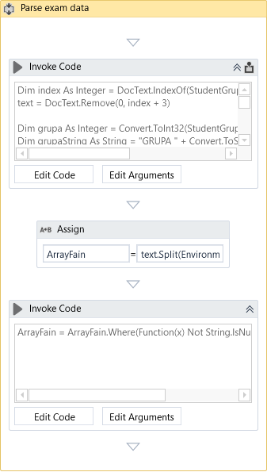

### II.3.5 The Create Google Calendar event sequence

This sequence is still in work. It opens the Google Calendar in the Google Chrome Browser and tries to create an event, but for some still unknown reason, it crushes. For the demo version we created, we replaced this sequence with another one that opens the Google Calendar and closes it without any other actions in between.

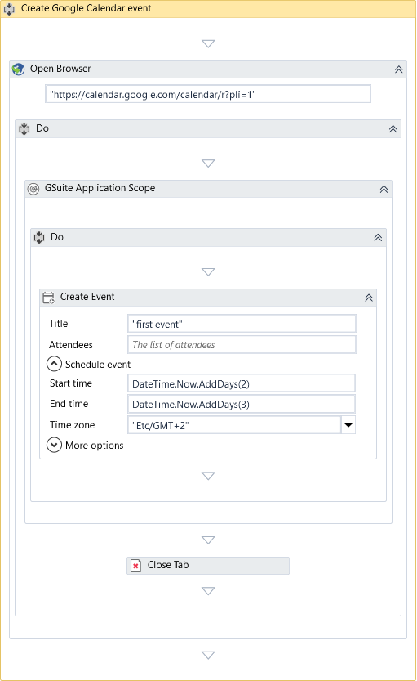

### II.3.6 The Send email to student sequence

This sequence corresponds to sending the confirmation email to the student, after creating the Google Calendar events, to let him know that the process has finished.

